A Mini Project Report on
MACHINE LEARNING BASED HEALTH PREDICTION SYSTEM USING IBM CLOUD AS PAAS
Submitted in Partial fulfillment of the requirements for the award of the degree of

BACHELOR OF TECHNOLOGY
In
INFORMATION TECHNOLOGY

Under the Guidance of
Mrs. R.G. VYSHNAVI
Assistant Professor

BY
Ms. Sanaboina Krupa Sree 18D21A1244
Ms. MuthireddyAshwitha 18D21A1231
Ms. Bombay Shree Latha 18D21A1207
Ms. E.G.Geetika 18D21A1213


Department Of Information Technology
SRIDEVI WOMEN’S ENGINEERING COLLEGE
(Approved by AICTE and Affiliated to JNTUH, and Accredited by NBA and NAAC
An ISO 9001:2015 Certified Institution)
V. N. PALLY, Gandipet-500075
2021-2022

Department Of Information Technology
SRIDEVI WOMEN’S ENGINEERING COLLEGE
(Approved by AICTE and Affiliated to JNTUH, and Accredited by NBA and NAAC
An ISO 9001:2015 Certified Institution)
V. N. PALLY, Gandipet-500075
2021-2022

CERTIFICATE

This is to certify that the Mini Project entitled “REAL TIME LOCALIZED AIR QUALITY MONITORING AND PREDICTION THROUGH MOBILE AND FIXED IOT SENSING NETWORK” is being submitted by Ms.SanaboinaKrupa Sree (18D21A1244),Ms.MuthireddyAshwitha(18D21A1231), Ms.BombayShreeLatha (18D21A1207), Ms.E.G.Geetika (18D21A1213)in partial fulfilment for the award of the Degree of Bachelor of Technology in INFORMATION TECHNOLOGY to the Jawaharlal Nehru Technological University, Hyderabad is a record of bonafied work carried out under my guidance and supervision. The results embodied in this project report have not been submitted to any other University or Institute for the award of any Degree or Diploma.

Under the Guidance of Coordinator Head of the Department

Mrs. R G Vyshnavi Dr. P.Avinash Dr. B.Narendra Kumar
(Assistant Professor) (Professor) (Professor and HOD)

EXTERNAL EXAMINER

DECLARATION

We hereby declare that the Mini Project entitled “REAL TIME LOCALIZED AIR QUALITY MONITORING AND PREDICTION THROUGH MOBILE AND FIXED IOT SENSING NETWORK” is the work done during the period from 10/09/2021 to 06/01/2022 and the same is submitted in partial fulfilment of the requirements for the award of degree of Bachelor of Technology in Information Technology from Jawaharlal Nehru Technological University, Hyderabad.

Ms. Sanaboina Krupa Sree (18D21A1244)
Ms. MuthireddyAshwitha (18D21A1231)
Ms. Bombay Shreelatha (18D21A1207)
Ms.E.GGeetika (18D21A1213)
`

ACKNOWLEDGEMENT
There are many people who helped us directly or indirectly to complete our mini project successfully. We would like to take this opportunity to thank one and all.
First of all, we would like to express our sincere gratitude and indebtedness to our internal guide Mrs. R G VYSHNAVI, Assistant Professor for her valuable guidance, suggestions, and keen personal interest throughout the course of this project and for her tireless patience in hearing our seminar, minutely seeing all the reports and giving appropriate guidance and suggestions.
It is our privilege and pleasure to express our deep sense of the indebtedness to coordinator, Dr. P. AVINASH, Professor, Department of IT for his timely cooperation and valuable suggestions throughout the project. We are indebted to him for the support given to us throughout the project work.
We would like to express our gratitude to Dr. B. NARENDRA KUMAR, Professor and Head of the Department of IT for his precious suggestions, motivations and cooperation for the successful completion of this project.
We are also extremely thankful to our principal Dr. B. L. MALLESWARI for her precious guidance and valuable suggestions.
Finally, we would like to thank all our faculty and friends for their help and constructive criticism during our project period. We are very much indebted to our parents for their moral support and encouragement to achieve goals.

Ms. SanaboinaKrupa sree (18D21A1244)
Ms. Muthireddy Ashwitha (18D21A1231)
Ms. Bombay.Shreelatha(18D21A1207)
Ms. E.G Geetika (18D21A1213)

ABSTRACT
Thyroid disorder leading cause of medical diagnosis and prediction development, which medical science is a complicated axiom. Thyroid gland is one of our body's main organs. Thyroid hormone secretions are responsible for regulating metabolism. Hyperthyroidism and hypothyroidism are the two prominent thyroid disorders that produce thyroid hormones for control of body metabolism. The machine learning is critical in the disease prediction process and in the study and classification models used for thyroid disease on the basis of data obtained from hospital datasets. A decent knowledge base must be ensured, built and used as a hybrid model to solve dynamic learning tasks like medical diagnosis and predictional tasks. Basic techniques of machine learning are used for the identification and inhibition of thyroid. The SVM is used to predict the approximate probability of a thyroid patient. If the patient has risk of getting thyroid our system has to give suggestions like recommending home remedies, precautions, medication etc…

TABLE OF CONTENTS

S.NO |  |  | NAME | PAGE NO.
1 |  |  | INTRODUCTION
 | 1.1 |  | PURPOSE
 | 1.2 |  | SCOPE
2 |  |  | LITERATURE SURVEY
3 |  |  | SYSTEM ANALYSIS
 | 3.1 |  | EXITING SYSTEM
 |  | 3.1.1 | DISADVANTAGES
 | 3.2 |  | PROPOSED SYSTEM
 |  | 3.2.1 | ADVANTAGES
4 |  |  | SOFTWARE REQUIREMENT SPECIFICATION
 | 4.1 |  | FUNCTIONAL REQUIREMENTS
 | 4.2 |  | NON-FUNCTIONAL REQUIREMENTS
 | 4.3 |  | HARDWARE REQUIREMENTS
 | 4.4 |  | SOFTWARE REQUIREMENTS
5 |  |  | SYSTEM DESIGN
 | 5.1 |  | SYSTEM SPECIFICATIONS
 | 5.2 |  | DATAFLOW DIAGRAM
 | 5.3 |  | MODULES
 | 5.4 |  | UML DIAGRAMS
 |  | 5.4.1 | USE CASE DIAGRAM
 |  | 5.4.2 | CLASS DIAGRAM
 |  | 5.4.3 | SEQUENCE DIAGRAM
 |  | 5.4.4 | COLLABORATION DIAGRAM
 |  | 5.4.5 | ACTIVITY DIAGRAM
 |  | 5.4.6 | COMPONENT DIAGRAM
 |  | 5.4.7 | DEPLOYMENT DIAGRAM
6 |  |  | IMPLEMENTATION
 | 6.1 |  | SAMPLE CODE
7 |  |  | SYSTEM TESTING
 | 7.1 |  | TESTING STRATEGIES
 | 7.2 |  | TEST CASES
 | 7.3 |  | RESULTS AND DISCUSSIONS
8 |  |  | CONCLUSION
 | 8.1 |  | CONCLUSION
REFERENCES

LIST OF FIGURES

S.NO | FIGURE NO. | FIGURE NAME | PAGE NO.
1 | 5.1 | System Architecture
2 | 5.2 | Data Flow Diagram
3 | 5.3.1 | Use case Diagram
4 | 5.3.2 | Class Diagram
5 | 5.3.3 | Sequence diagram
6 | 5.3.4 | Collaboration diagram
7 | 5.3.5 | Activity Diagram
8 | 5.3.6 | Component Diagram
9 | 5.3.7 | Deployment Diagram
10 | 7.3.1 | Output screen
11 | 7.3.2 | Output screen
12 | 7.3.3 | Output screen
13 | 7.3.4 | Output screen
14 | 7.3.5 | Output screen
15 | 7.3.6 | Output screen
16 | 7.3.7 | Output screen
17 | 7.3.8 | Output screen
18 | 7.3.9 | Output screen
19 | 7.3.10 | Output screen
20 | 7.3.11 | Output screen
21 | 7.3.12 | Output screen
22 | 7.3.13 | Output screen
23 | 7.3.14 | Output screen
24 | 7.3.15 | Output screen
25 | 7.3.16 | Output screen
26 | 7.3.17 | Output screen
27 | 7.3.18 | Output screen
28 | 7.3.19 | Output screen
29 | 7.3.19 | Output screen

LIST OF TABLES

S.NO | TABLE NO. | TABLE NAME | PAGENO.
1 | 7.1 | Test Cases

CHAPTER 1
INTRODUCTION

  - PURPOSE
Advanced machine biology is used in the area of healthcare. It required data to be collected for medical disease prediction. For early-stage disease detection, various intelligent prediction algorithms are used. The Medical Information System is good with data sets, but intelligent systems are not available for the fast diagnosis of diseases. Eventually, machine learning algorithms play a key position in solving complex and non-linear problems during the creation of prediction model. The characteristics that can be selected from the various data sets that can be used as description in a healthy patient as specifically as possible are needed in any disease prediction models. Otherwise, misclassification can result in a good patient receiving inappropriate care.
1.2 SCOPE
The reality of forecasting any condition associated with thyroid illness is also of the greatest cardinal number. Thyroid gland is endocrine in stomach. It is erected in lowered portion of human neck, under apple of Adam, and assists in secretion of thyroid hormones and which ultimately affects metabolism rate and protein synthesis. To control body metabolism, these hormones count on how quickly heart beats and how quickly calories burn. The composition of thyroid hormones helps to control the body's metabolism. These glands consist of two mature levothyroxine (abbreviated T4) and triiodothyronine thyroid hormones (abbreviated T3). These thyroid hormones are essential for manufacturing and general construction and regulation in order to regulate body temperature. T4 and T3 are exclusively two activated thyroid hormones that usually compose of thyroid glands.

CHAPTER 2
LITERATURE SURVEY
2.1 Diagnosis of Thyroid disorder using Artificial Neural Networks
AUTHORS: Anupam Shukla,Ritu Tiwari,Prabhdeep Kaur,R.R. Janghel
ABSTRACT: A major problem in medical science is attaining the correct diagnosis of disease in precedence of its treatment. This paper presents the diagnosis of thyroid disorders using artificial neural networks (ANNs). The feed-forward neural network has been trained using three ANN algorithms; the Back propagation algorithm (BPA), the radial basis function (RBF) Networks and the learning vector quantization (LVQ) networks. The networks are simulated using MATLAB and their performance is assessed in terms of factors like accuracy of diagnosis and training time. The performance comparison helps to find out the best model for diagnosis of thyroid disorders.
2.2 A novel hybrid method based on artificial immune recognition system (AIRS) with fuzzy weighted pre-processing for thyroid disease diagnosis
AUTHORS: Kemal Polat,Seral Özşen,Salih Güneş
ABSTRACT: Proper interpretation of the thyroid gland functional data is an important issue in the diagnosis of thyroid disease. The primary role of the thyroid gland is to help regulation of the body’s metabolism. Thyroid hormone produced by the thyroid gland provides this. Production of too little thyroid hormone (hypothyroidism) or production of too much thyroid hormone (hyperthyroidism) defines the type of thyroid disease. Artificial immune systems (AISs) is a new but effective branch of artificial intelligence. Among the systems proposed in this field so far, artificial immune recognition system (AIRS), which was proposed by A. Watkins, has shown an effective and intriguing performance on the problems it was applied. This study aims at diagnosing thyroid disease with a new hybrid machine learning method including this classification system. By hybridizing AIRS with a developed Fuzzy weighted pre-processing, a method is obtained to solve this diagnosis problem via classifying. The robustness of this method with regard to sampling variations is examined using a cross-validation method. We used thyroid disease dataset which is taken from UCI machine learning respiratory. We obtained a classification accuracy of 85%, which is the highest one reached so far. The classification accuracy was obtained via a 10-fold cross-validation.
2.3 An investigation of neural networks in thyroid function diagnosis
AUTHORS: G Zhang, V L Berardi
ABSTRACT: We investigate the potential of artificial neural networks in diagnosing thyroid diseases. The robustness of neural networks with regard to sampling variations is examined using a cross-validation method. We illustrate the link between neural networks and traditional Bayesian classifiers. Neural networks can provide good estimates of posterior probabilities and hence can have better classification performance than traditional statistical methods such as logistic regression. The neural network models are further shown to be robust to sampling variations. It is demonstrated that for medical diagnosis problems where the data are often highly unbalanced, neural networks can be a promising classification method for practical use.

2.4 A survey on applying machine learning techniques for management of diseases
AUTHORS: Enas M.F. El Houby
ABSTRACT: During the past years, the increase in scientific knowledge and the massive data production have caused an exponential growth in databases and repositories. Biomedical domain represents one of the rich data domains. An extensive amount of biomedical data is currently available, ranging from details of clinical symptoms to various types of biochemical data and outputs of imaging devices. Manually extracting biomedical patterns from data and transforming them into machine-understandable knowledge is a difficult task because biomedical domain comprises huge, dynamic, and complicated knowledge. Data mining is capable of improving the quality of extracting biomedical patterns. In this research, an overview of the applications of data mining on the management of diseases is presented. The main focus is to investigate machine learning techniques (MLT) which are widely used to predict, prognose and treat important frequent diseases such as cancers, hepatitis and heart diseases. The techniques namely Artificial Neural Network, K-Nearest Neighbour, Decision Tree, and Associative Classification are illustrated and analyzed. This survey provides a general analysis of the current status of management of diseases using MLT. The achieved accuracy of the various applications ranged from 70% to 100% according to the disease, the solved problem, and the used data and technique.

CHAPTER 3
SYSTEM ANALYSIS
3.1 EXISTING SYSTEM:
Thyroid disorder significant cause of formation of medical diagnosis and estimation, which is a challenging axiom of medical science. The secretions of thyroid hormones are guilty of metabolism regulation. Hyperthyroidism and hypothyroidism are one of the two prevalent thyroid disorders that release thyroid hormones to control body metabolism. Data c leaning methods have been used to make data primitive enough to do analytics to demonstrate likelihood of patients having thyroid.
3.1.1 DISADVANTAGES OF EXISTING SYSTEM:
1.Medical research is based on a complex axiom, and the major cause of medical diagnosis and prediction development is thyroid condition.
2.Machine learning is essential for studying and classifying thyroid illness based on data from hospital datasets and for the disease prediction process.

  - PROPOSED SYSTEM:

In the prediction process, machine learning plays a key role, and paper research and the classifications of models used in thyroid disease are based on information from UCI machine learning repositories. A decent knowledge base that can be centered and used as a hybrid paradigm must be preserved in order to address complex learning issues, such as medical diagnostics and statistical tasks. We also proposed different approaches for machine learning and thyroid diagnosis. Machine Learning Algorithms, Vector Support Machine, Decision Trees, K-NN were used to calculate an estimated probability of a patient having thyroid disease.
3.2.1 ADVANTAGES OF PROPOSED SYSTEM:
1. Avoids long-term risks of anti-thyroid and radioactive iodine.
2. Provides histology tissue, for childbearing instantly.

3.3 SRS SOFTWARE REQUIREMENT SPECIFICATIONS
Systems Development Life Cycle
The Systems Development Life Cycle (SDLC), or Software Development Life Cycle in systems engineering, information systems and software engineering, is the process of creating or altering systems, and the models and methodologies that people use to develop these systems.
In software engineering the SDLC concept underpins many kinds of software development methodologies. These methodologies form the framework for planning and controlling the creation of an information system the software development process.
SOFTWARE MODEL OR ARCHITECTURE ANALYSIS:
Structured project management techniques (such as an SDLC) enhance management’s control over projects by dividing complex tasks into manageable sections. A software life cycle model is either a descriptive or prescriptive characterization of how software is or should be developed. But none of the SDLC models discuss the key issues like Change management, Incident management and Release management processes within the SDLC process, but, it is addressed in the overall project management. In the proposed hypothetical model, the concept of user-developer interaction in the conventional SDLC model has been converted into a three dimensional model which comprises of the user, owner and the developer. In the proposed hypothetical model, the concept of user-developer interaction in the conventional SDLC model has been converted into a three dimensional model which comprises of the user, owner and the developer. The ―one size fits all‖ approach to applying SDLC methodologies is no longer appropriate. We have made an attempt to address the above mentioned defects by using a new hypothetical model for SDLC described elsewhere. The drawback of addressing these management processes under the overall project management is missing of key technical issues pertaining to software development process that is, these issues are talked in the project management at the surface level but not at the ground level.

WHAT IS SDLC?

A software cycle deals with various parts and phases from planning to testing and deploying software. All these activities are carried out in different ways, as per the needs. Each way is known as a Software Development Lifecycle Model (SDLC). A software life cycle model is either a descriptive or prescriptive characterization of how software is or should be developed. A descriptive model describes the history of how a particular software system was developed. Descriptive models may be used as the basis for understanding and improving software development processes or for building empirically grounded prescriptive models.
SDLC models * The Linear model (Waterfall) - Separate and distinct phases of specification and development. - All activities in linear fashion. - Next phase starts only when first one is complete. * Evolutionary development - Specification and development are interleaved (Spiral, incremental, prototype based, Rapid Application development). - Incremental Model (Waterfall in iteration), - RAD(Rapid Application Development) - Focus is on developing quality product in less time, - Spiral Model - We start from smaller module and keeps on building it like a spiral. It is also called Component based development. * Formal systems development - A mathematical system model is formally transformed to an implementation. * Agile Methods. - Inducing flexibility into development. * Reuse-based development - The system is assembled from existing components.

The General Model
Software life cycle models describe phases of the software cycle and the order in which those phases are executed. There are tons of models, and many companies adopt their own, but all have very similar patterns. Each phase produces deliverables required by the next phase in the life cycle. Requirements are translated into design. Code is produced during implementation that is driven by the design. Testing verifies the deliverable of the implementation phase against requirements.
SDLC Methodology:
Spiral Model
The spiral model is similar to the incremental model, with more emphases placed on risk analysis. The spiral model has four phases: Planning, Risk Analysis, Engineering and Evaluation. A\ software project repeatedly passes through these phases in iterations (called Spirals in this model). The baseline spiral, starting in the planning phase, requirements is gathered and risk is assessed. Each subsequent spirals builds on the baseline spiral. Requirements are gathered during the planning phase. In the risk analysis phase, a process is undertaken to identify risk and alternate solutions. A prototype is produced at the end of the
risk analysis phase. Software is produced in the engineering phase, along with testing at
the end of the phase. The evaluation phase allows the customer to evaluate the output of the project to date before the project continues to the next spiral. In the spiral model, the angular component represents progress, and the radius of the spiral represents cost. Spiral Life Cycle Model.
This document play a vital role in the development of life cycle (SDLC) as it describes the complete requirement of the system. It means for use by developers and will be the basic during testing phase. Any changes made to the requirements in the future will have to go through formal change approval process.
SPIRAL MODEL was defined by Barry Boehm in his 1988 article, “A spiral Model of Software Development and Enhancement. This model was not the first model to discuss iterative development, but it was the first model to explain why the iteration models.
As originally envisioned, the iterations were typically 6 months to 2 years long. Each phase starts with a design goal and ends with a client reviewing the progress thus far. Analysis and engineering efforts are applied at each phase of the project, with an eye toward the end goal of the project.
The steps for Spiral Model can be generalized as follows:
- The new system requirements are defined in as much details as possible. This usually involves interviewing a number of users representing all the external or internal users and other aspects of the existing system.
- A preliminary design is created for the new system.
- A first prototype of the new system is constructed from the preliminary design. This is usually a scaled-down system, and represents an approximation of the characteristics of the final product.
- A second prototype is evolved by a fourfold procedure:
- Evaluating the first prototype in terms of its strengths, weakness, and risks.
- Defining the requirements of the second prototype.
- Planning an designing the second prototype.
- Constructing and testing the second prototype.
- At the customer option, the entire project can be aborted if the risk is deemed too great. Risk factors might involved development cost overruns, operating-cost miscalculation, or any other factor that could, in the customer’s judgment, result in a less-than-satisfactory final product.
- The existing prototype is evaluated in the same manner as was the previous prototype, and if necessary, another prototype is developed from it according to the fourfold procedure outlined above.
- The preceding steps are iterated until the customer is satisfied that the refined prototype represents the final product desired.
- The final system is constructed, based on the refined prototype.
- The final system is thoroughly evaluated and tested. Routine maintenance is carried on a continuing basis to prevent large scale failures and to minimize down time.
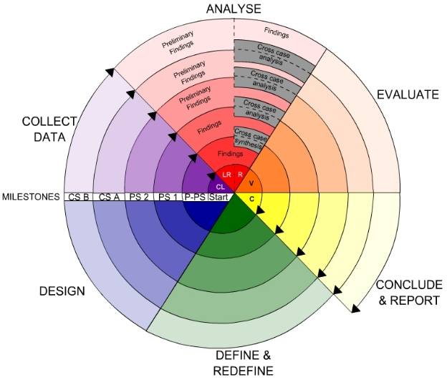
Fig -Spiral Model
Advantages
- High amount of risk analysis
- Good for large and mission-critical projects.
- Software is produced early in the software life cycle.

CHAPTER 4
SYSTEM REQUIREMENT SPECIFICATION
4.1 HARDWARE REQUIREMENTS
Minimum hardware requirements are very dependent on the particular software being developed by a given though Python / Canopy / VS Code user. Applications that need to store large arrays/objects in memory will require more RAM, whereas applications that need to perform numerous calculations or tasks more quickly will require a faster processor.

- Operating system : Windows 10
- Processor : Intel i5
- Ram : 4 GB
- Hard disk : 250 GB

4.2 SOFTWARE REQIREMENTS
The functional requirements or the overall description documents include the product perspective and features, operating system and operating environment, graphics requirements, design constraints and user documentation.
The appropriation of requirements and implementation constraints gives the general overview of the project in regards to what the areas of strength and deficit are and how to tackle them.

- Operating System - Windows7/8
- Programming Language - Python 3.7

4.3 FUNCTIONAL REQUIREMENTS

- Upload Thyroid Dataset
- Data Preprocessing
- Feature Extraction
- Build SVM & PCA with SVM Classifiers
- Upload Test Data
- Predict Diseases With Suggestions

SOME EXAMPLES OF FUNCTIONAL REQUIREMENTS:
1.The System must only allow user with valid id and password to enter the system.
2.The System performs authorization process which decides what user level can access to.
3.The User must be able to logout after they finished using system.

3.5 NON FUNCTIONAL REQUIREMENTS
Usability
Usability is the main non-functional requirement for the “Prediction And Providing Medication For Thyroid Disease Using Machine Learning Technique”.The UI should be simple enough for everyone to understand and get the relevant information without any special training. Different languages can be provided based on the requirements.
Accuracy
Accuracy is another important non-functional requirement for the “Prediction And Providing Medication For Thyroid Disease Using Machine Learning Technique”. The dataset is used to Train and Test Model in python .Prediction should be correct, consistent, and reliable.
Availability
The System should be available for the duration when the user operates and must be recovered within an hour or less if it fails. The system should respond to the requests within two seconds or less.
Maintainability
The software should be easily maintainable and adding new features and making changes to the software must be as simple as possible. In addition to this, the software must also be portable.

SOME EXAMPLES OF NON-FUNCTIONAL REQUIREMENTS:
1.Users must change the initially assigned login password immediately after the first successful login. Moreover, the initial should never be reused.
2.Every unsuccessful attempt by a user to access an item of data shall be recorded on an audit trail.
3.A website should be capable enough to handle 20 million users with affecting its performance
4.The software should be portable. So moving from one OS to other OS does not create any problem.
5.Privacy of information, the export of restricted technologies, intellectual property rights, etc. should be audited.

4.5 SYSTEM STUDY
FEASIBILITY STUDY
The feasibility of the project is analyzed in this phase and business proposal is put forth with a very general plan for the project and some cost estimates. During system analysis the feasibility study of the proposed system is to be carried out. This is to ensure that the proposed system is not a burden to the company. For feasibility analysis, some understanding of the major requirements for the system is essential.
Three key considerations involved in the feasibility analysis are
- ECONOMICAL FEASIBILITY
- TECHNICAL FEASIBILITY
- SOCIAL FEASIBILITY

ECONOMICAL FEASIBILITY
This study is carried out to check the economic impact that the system will have on the organization. The amount of fund that the company can pour into the research and development of the system is limited. The expenditures must be justified. Thus the developed system as well within the budget and this was achieved because most of the technologies used are freely available. Only the customized products had to be purchased.

TECHNICAL FEASIBILITY
This study is carried out to check the technical feasibility, that is, the technical requirements of the system. Any system developed must not have a high demand on the available technical resources. This will lead to high demands on the available technical resources. This will lead to high demands being placed on the client. The developed system must have a modest requirement, as only minimal or null changes are required for implementing this system.

SOCIAL FEASIBILITY
The aspect of study is to check the level of acceptance of the system by the user. This includes the process of training the user to use the system efficiently. The user must not feel threatened by the system, instead must accept it as a necessity. The level of acceptance by the users solely depends on the methods that are employed to educate the user about the system and to make him familiar with it. His level of confidence must be raised so that he is also able to make some constructive criticism, which is welcomed, as he is the final user of the system.

CHAPTER 5
SYSTEM DESIGN
5.1 SYSTEM SPECIFICATION
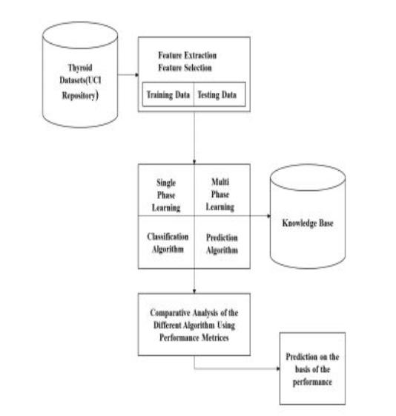

Figure 5.1 System Architecture

DATA FLOW DIAGRAM:

- The DFD is also called as bubble chart. It is a simple graphical formalism that can be used to represent a system in terms of input data to the system, various processing carried out on this data, and the output data is generated by this system.
- The data flow diagram (DFD) is one of the most important modeling tools. It is used to model the system components. These components are the system process, the data used by the process, an external entity that interacts with the system and the information flows in the system.
- DFD shows how the information moves through the system and how it is modified by a series of transformations. It is a graphical technique that depicts information flow and the transformations that are applied as data moves from input to output.
- DFD is also known as bubble chart. A DFD may be used to represent a system at any level of abstraction. DFD may be partitioned into levels that represent increasing information flow and functional detail.

LEVEL 0:
Dataset

Thyroid Dataset
Upload Thyroid Dataset Upload Test Data
Prediction And Providing Medication For Thyroid Disease Using Machine Learning Technique
User
Application

Predict Diseases with Suggestions

LEVEL 1:
Prediction And Providing Medication For Thyroid Disease Using Machine Learning Technique
Sign in report
SQLite database
User

User details details

LEVEL 2:
User
Dataset
Upload Thyroid Dataset Datapreprocessing
Prediction And Providing Medication For Thyroid Disease Using Machine Learning Technique

Predict Diseases with Suggestions Load Dataset Train & Test data

user details
login success
SQLite database

4.3 UML DIAGRAMS

UML stands for Unified Modeling Language. UML is a standardized general-purpose modeling language in the field of object-oriented software engineering. The standard is managed, and was created by, the Object Management Group.
The goal is for UML to become a common language for creating models of object oriented computer software. In its current form UML is comprised of two major components: a Meta-model and a notation. In the future, some form of method or process may also be added to; or associated with, UML.
The Unified Modeling Language is a standard language for specifying, Visualization, Constructing and documenting the artifacts of software system, as well as for business modeling and other non-software systems.
The UML represents a collection of best engineering practices that have proven successful in the modeling of large and complex systems.
The UML is a very important part of developing objects oriented software and the software development process. The UML uses mostly graphical notations to express the design of software projects.

GOALS:
The Primary goals in the design of the UML are as follows:
- Provide users a ready-to-use, expressive visual modeling Language so that they can develop and exchange meaningful models.
- Provide extendibility and specialization mechanisms to extend the core concepts.
- Be independent of particular programming languages and development process.
- Provide a formal basis for understanding the modeling language.
- Encourage the growth of OO tools market.
- Support higher level development concepts such as collaborations, frameworks, patterns and components.
- Integrate best practices.

Use case diagram:
A use case diagram in the Unified Modeling Language (UML) is a type of behavioral diagram defined by and created from a Use-case analysis. Its purpose is to present a graphical overview of the functionality provided by a system in terms of actors, their goals (represented as use cases), and any dependencies between those use cases. The main purpose of a use case diagram is to show what system functions are performed for which actor. Roles of the actors in the system can be depicted.

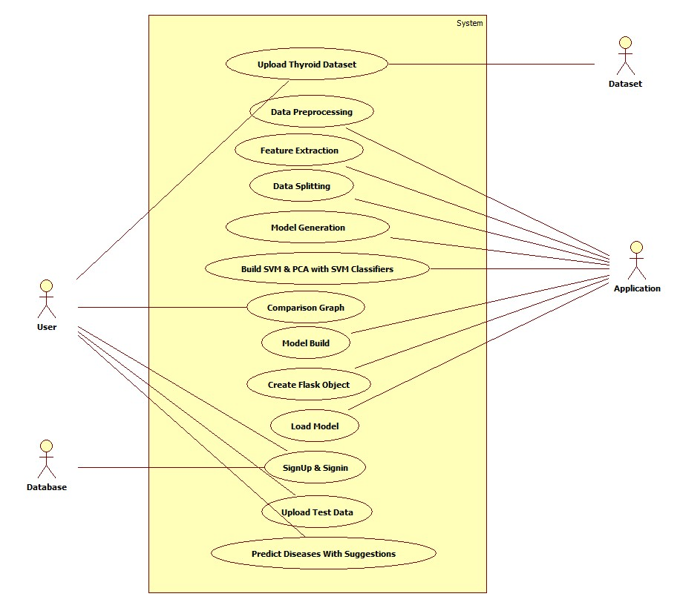

Class diagram:
The class diagram is used to refine the use case diagram and define a detailed design of the system. The class diagram classifies the actors defined in the use case diagram into a set of interrelated classes. The relationship or association between the classes can be either an "is-a" or "has-a" relationship. Each class in the class diagram may be capable of providing certain functionalities. These functionalities provided by the class are termed "methods" of the class. Apart from this, each class may have certain "attributes" that uniquely identify the class.
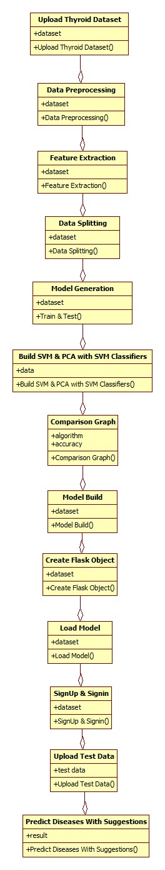

Object diagram:
The object diagram is a special kind of class diagram. An object is an instance of a class. This essentially means that an object represents the state of a class at a given point of time while the system is running. The object diagram captures the state of different classes in the system and their relationships or associations at a given point of time.

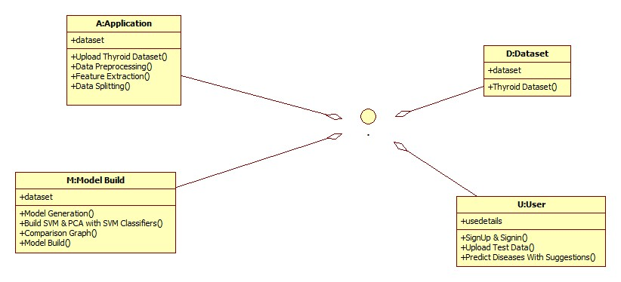

State diagram:
A state diagram, as the name suggests, represents the different states that objects in the system undergo during their life cycle. Objects in the system change states in response to events. In addition to this, a state diagram also captures the transition of the object's state from an initial state to a final state in response to events affecting the system.
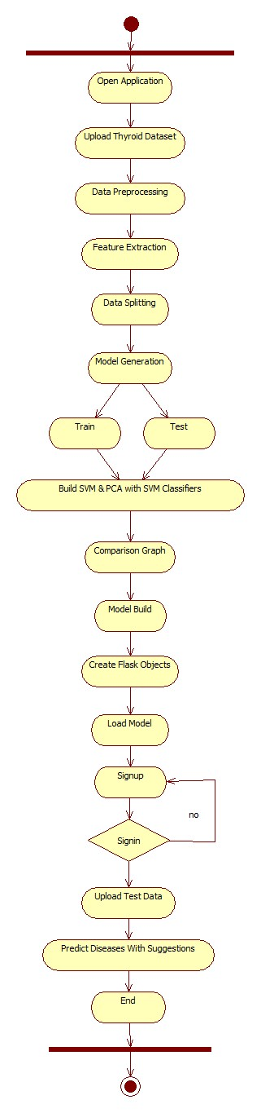

Activity diagram:
The process flows in the system are captured in the activity diagram. Similar to a state diagram, an activity diagram also consists of activities, actions, transitions, initial and final states, and guard conditions.
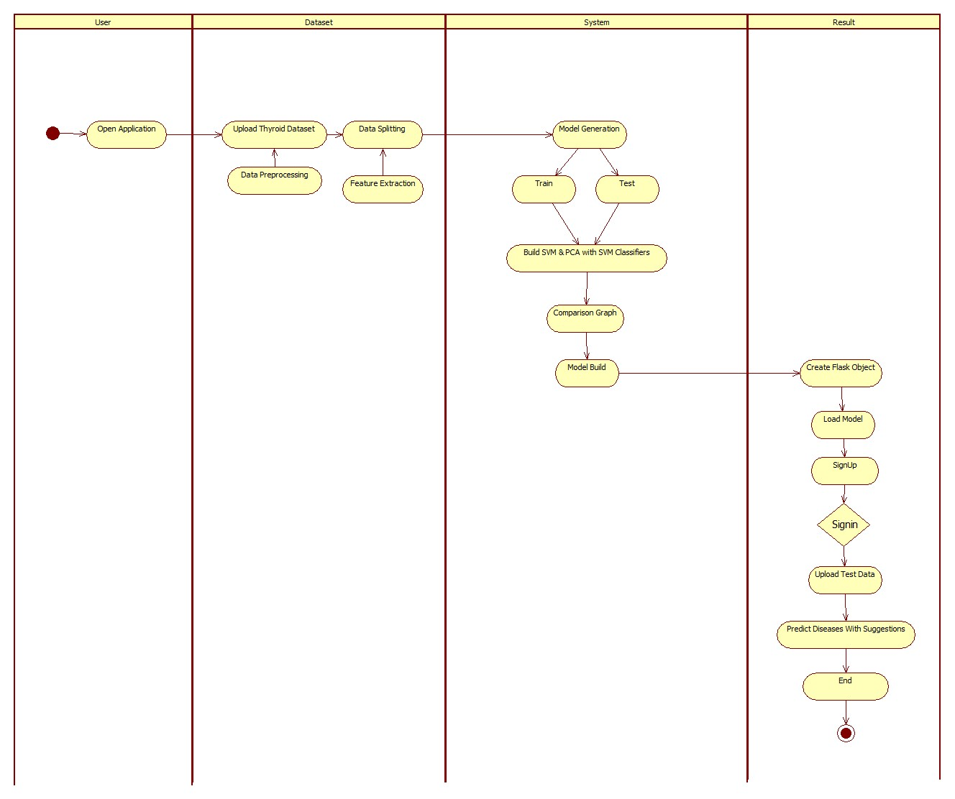
Sequence diagram:
A sequence diagram represents the interaction between different objects in the system. The important aspect of a sequence diagram is that it is time-ordered. This means that the exact sequence of the interactions between the objects is represented step by step. Different objects in the sequence diagram interact with each other by passing "messages".

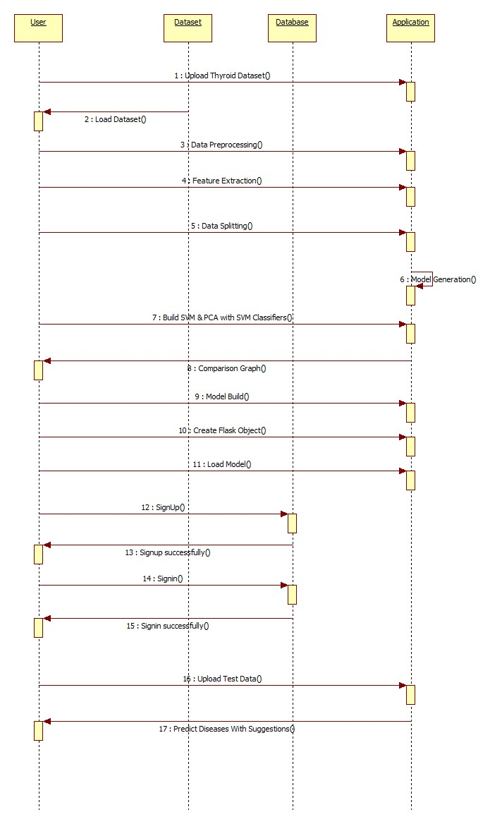
Collaboration diagram:
A collaboration diagram groups together the interactions between different objects. The interactions are listed as numbered interactions that help to trace the sequence of the interactions. The collaboration diagram helps to identify all the possible interactions that each object has with other objects.
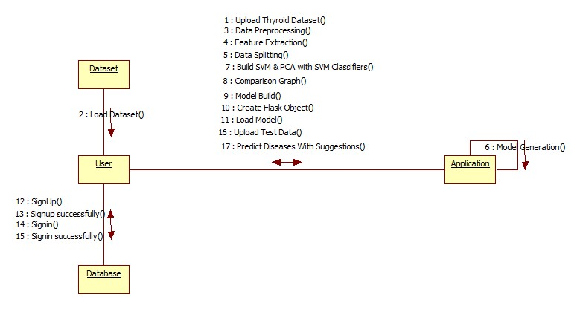

Component diagram:
The component diagram represents the high-level parts that make up the system. This diagram depicts, at a high level, what components form part of the system and how they are interrelated. A component diagram depicts the components culled after the system has undergone the development or construction phase.
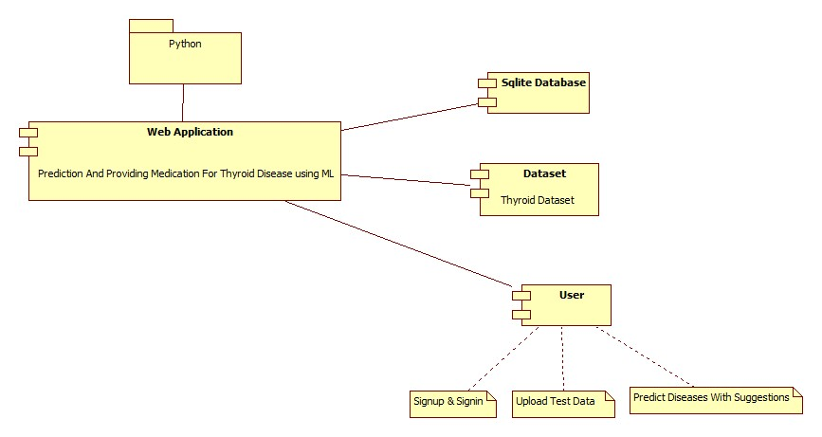
Deployment diagram:
The deployment diagram captures the configuration of the runtime elements of the application. This diagram is by far most useful when a system is built and ready to be deployed.

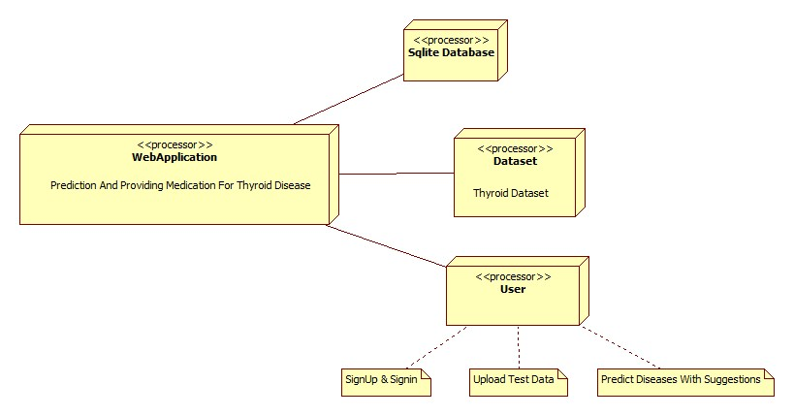

Modules:

1.Data Collection
This step was done by the original owners of the dataset. And the composition of the dataset.understand the relationship among different features. A plot of the core features and the entire dataset.The dataset is further split into 2/3 for training and 1/3 for testing the algorithms. Furthermore, in order to obtain a representative sample, each class in the full dataset is represented in about the right proportion in both the training and testing datasets. The various proportions of the training and testing datasets used in the paper.
2.Data Preprocessing
The data which was collected might contain missing values that may lead to inconsistency. To gain better results data need to be preprocessed so as to improve the efficiency o the algorithm. The outliers have to be removed and also variable conversion need to be done. In order to overcoming these issues we use map function.

3.Model Selection
Machine learning is about predicting and recognizing patterns and generate suitable results after understanding them. ML algorithms study patterns in data and learn from them. An ML model will learn and improve on each attempt. To gauge the effectiveness of a model, it’s vital to split the data into training and test sets first. So before training our models, we split the data into Training set which was 70% of the whole dataset and Test set which was the remaining 30%. Model accuracy might not be the sole metric to identify how our model performed- the F1 score and confusion matrix should be important metrics to analyse as well. What is important is that the right performance measures are chosen for the right situations.
4.Predict the results
The designed system is tested with test set and the performance is assured. Evolution analysis refers to the description and model regularities or trends for objects whose behavior changes over time. Common metrics calculated from the confusion matrix are Precision; Accuracy. The mot important features since these features are to develop a predictive model using ordinary SVM model.

CHAPTER 6
IMPLEMENTATION
ALGORITHM:
SUPPORT VECTOR MACHINE(SVM)
“Support Vector Machine” (SVM) is a supervised machine learning algorithm which can be used for both classification or regression challenges. However, it is mostly used in classification problems. In this algorithm, we plot each data item as a point in n-dimensional space (where n is number of features you have) with the value of each feature being the value of a particular coordinate. Then, we perform classification by finding the hyper-plane that differentiate the two classes very well (look at the below snapshot). The SVM algorithm is implemented in practice using a kernel. The learning of the hyperplane in linear SVM is done by transforming the problem using some linear algebra, which is out of the scope of this introduction to SVM. A powerful insight is that the linear SVM can be rephrased using the inner product of any two given observations, rather than the observations themselves. The inner product between two vectors is the sum of the multiplication of each pair of input values. For example, the inner product of the vectors [2, 3] and [5, 6] is 2*5 + 3*6 or 28. The equation for making a prediction for a new input using the dot product between the input (x) and each support vector (xi) is calculated as follows:
f(x) = B0 + sum(ai * (x,xi))

This is an equation that involves calculating the inner products of a new input vector (x) with all support vectors in training data. The coefficients B0 and ai (for each input) must be estimated from the training data by the learning algorithm.
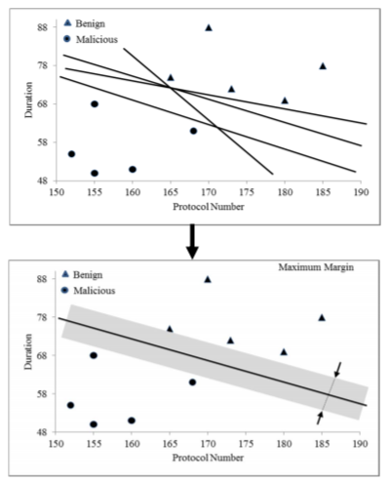
Multi-layer ANN
Deep Learning deals with training multi-layer artificial neural networks, also called Deep Neural Networks. After Rosenblatt perceptron was developed in the 1950s, there was a lack of interest in neural networks until 1986, when Dr.Hinton and his colleagues developed the backpropagation algorithm to train a multilayer neural network. Today it is a hot topic with many leading firms like Google, Facebook, and Microsoft which invest heavily in applications using deep neural networks.
Multi-layer ANN
A fully connected multi-layer neural network is called a Multilayer Perceptron (MLP).
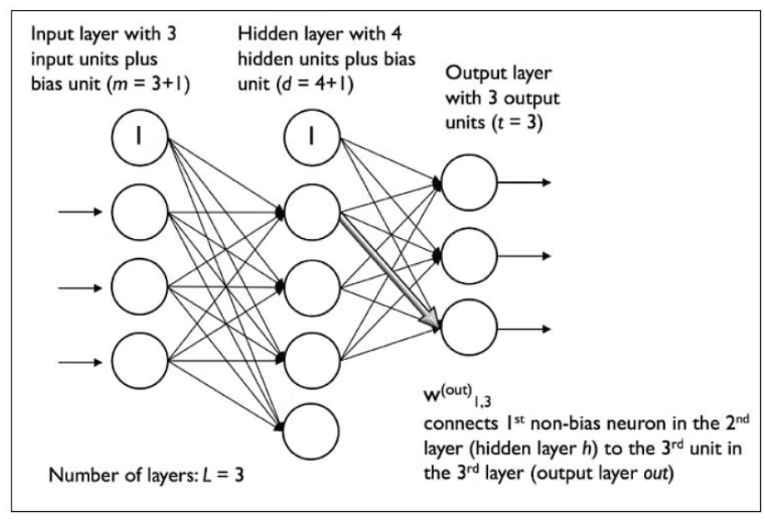

It has 3 layers including one hidden layer. If it has more than 1 hidden layer, it is called a deep ANN. An MLP is a typical example of a feedforward artificial neural network. In this figure, the ith activation unit in the lth layer is denoted as ai(l).
The number of layers and the number of neurons are referred to as hyper parameters of a neural network, and these need tuning. Cross-validation techniques must be used to find ideal values for these.
The weight adjustment training is done via back propagation. Deeper neural networks are better at processing data. However, deeper layers can lead to vanishing gradient problems. Special algorithms are required to solve this issue.
Random Forest Algorithm
Random Forest algorithm is a supervised classification algorithm. We can see it from its name, which is to create a forest by some way and make it random. There is a direct relationship between the number of trees in the forest and the results it can get: the larger the number of trees, the more accurate the result. But one thing to note is that creating the forest is not the same as constructing the decision with information gain or gain index approach. The decision tree is a decision support tool. It uses a tree-like graph to show the possible consequences. If you input a training dataset with targets and features into the decision tree, it will formulate some set of rules. These rules can be used to perform predictions. When we have our dataset categorized into 3 category so now Random forest helps to make classes from the dataset. Random forest is clusters of decision trees all together, if you input a training dataset with features and labels into a decision tree, it will formulate some set of rules, which will be used to make the predictions.
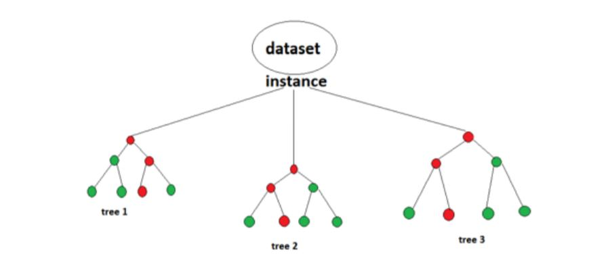

Naive Bayes Classifier:
Naive Bayes is a classification technique with a notion which defines all features are independent and unrelatedto each other. It defines that status of a specific feature in a class does not affect the status of another feature. Sinceit is based on conditional probability it is considered as a powerful algorithm employed for classification purpose.It works well for the data with imbalancing problems and missing values. Naive Bayes is a machine learningclassifier which employs the Bayes Theorem. Using Bayes theorem posterior probability
P(C|X) can be calculated from P(C),P(X) and P(X|C).
Therefore,P(C|X)=(P(X|C)
P(C))/P(X)
Where,P(C|X)=target class’s posterior probability .
P(X|C)=predictor class’s probability.
P(C)=class C’s probability being true.
P(X)=predictor’s prior probability.
Decision Tree Classifier:
Decision Tree is a supervised machine learning algorithm used to solve classification problems. The main objectiveof using Decision Tree in this research work is the prediction of target class using decision rule taken from prior data.It uses nodes and internodes for the prediction and classification. Root nodes classify the instances with differentfeatures. Root nodes can have two or more branches while the leaf nodes represent classification. In every stage, Decision tree chooses each node by evaluating the highest information gain among all the attributes. The evaluated performance of Decision Tree technique
Boosting:
Boosting is an ensemble modelling technique that was first presented by Freund and Schapire in the year 1997, since then, Boosting has been a prevalent technique for tackling binary classification problems. These algorithms improve the prediction power by converting a number of weak learners to strong learners. The principle behind boosting algorithms is first we built a model on the training dataset, then a second model is built to rectify the errors present in the first model. This procedure is continued until and unless the errors are minimized, and the dataset is predicted correctly. Let’s take an example to understand this, suppose you built a decision tree algorithm on the Titanic dataset and from there you get an accuracy of 80%. After this, you apply a different algorithm and check the accuracy and it comes out to be 75% for KNN and 70% for Linear Regression. We see the accuracy differs when we built a different model on the same dataset. But what if we use combinations of all these algorithms for making the final prediction? We’ll get more accurate results by taking the average of results from these models. We can increase the prediction power in this way. Boosting algorithms works in a similar way, it combines multiple models (weak learners) to reach the final output (strong learners). In this article, we will understand the math behind different types of boosting algorithms. There are mainly 3 types of boosting algorithms: AdaBoost algorithm Gradient descent algorithm Xtreme gradient descent algorithm
Gradient Boosting Algorithm:Gradient boosting classifiers are a group of machine learning algorithms that combine many weak learning models together to create a strong predictive model. Decision trees are usually used when doing gradient boosting. Gradient boosting models are becoming popular because of their effectiveness at classifying complex datasets, and have recently been used to win many Kaggle data science competitions.

Logistic Regression: The logistic regression is a predictive analysis. Logistic regression is used to describe data and to explain the relationship between one dependent binary variable and one or more nominal, ordinal, interval or ratio-level independent variables.

SOFTWARE ENVIRONMENT

What is Python :-
Below are some facts about Python.
Python is currently the most widely used multi-purpose, high-level programming language.
Python allows programming in Object-Oriented and Procedural paradigms. Python programs generally are smaller than other programming languages like Java.
Programmers have to type relatively less and indentation requirement of the language, makes them readable all the time.
Python language is being used by almost all tech-giant companies like – Google, Amazon, Facebook, Instagram, Dropbox, Uber… etc.
The biggest strength of Python is huge collection of standard library which can be used for the following –
  - Machine Learning
  - GUI Applications (like Kivy, Tkinter, PyQt etc. )
  - Web frameworks like Django (used by YouTube, Instagram, Dropbox)
  - Image processing (like Opencv, Pillow)
  - Web scraping (like Scrapy, BeautifulSoup, Selenium)
  - Test frameworks
  - Multimedia

Advantages of Python :-
Let’s see how Python dominates over other languages.

1. Extensive Libraries
Python downloads with an extensive library and it contain code for various purposes like regular expressions, documentation-generation, unit-testing, web browsers, threading, databases, CGI, email, image manipulation, and more. So, we don’t have to write the complete code for that manually.

2. Extensible
As we have seen earlier, Python can be extended to other languages. You can write some of your code in languages like C++ or C. This comes in handy, especially in projects.

3. Embeddable
Complimentary to extensibility, Python is embeddable as well. You can put your Python code in your source code of a different language, like C++. This lets us add scripting capabilities to our code in the other language.

4. Improved Productivity
The language’s simplicity and extensive libraries render programmers more productive than languages like Java and C++ do. Also, the fact that you need to write less and get more things done.

5. IOT Opportunities
Since Python forms the basis of new platforms like Raspberry Pi, it finds the future bright for the Internet Of Things. This is a way to connect the language with the real world.

6. Simple and Easy
When working with Java, you may have to create a class to print ‘Hello World’. But in Python, just a print statement will do. It is also quite easy to learn, understand, and code. This is why when people pick up Python, they have a hard time adjusting to other more verbose languages like Java.

7. Readable
Because it is not such a verbose language, reading Python is much like reading English. This is the reason why it is so easy to learn, understand, and code. It also does not need curly braces to define blocks, and indentation is mandatory. This further aids the readability of the code.

8. Object-Oriented
This language supports both the procedural and object-oriented programming paradigms. While functions help us with code reusability, classes and objects let us model the real world. A class allows the encapsulation of data and functions into one.

9. Free and Open-Source
Like we said earlier, Python is freely available. But not only can you download Python for free, but you can also download its source code, make changes to it, and even distribute it. It downloads with an extensive collection of libraries to help you with your tasks.

10. Portable
When you code your project in a language like C++, you may need to make some changes to it if you want to run it on another platform. But it isn’t the same with Python. Here, you need to code only once, and you can run it anywhere. This is called Write Once Run Anywhere (WORA). However, you need to be careful enough not to include any system-dependent features.

11. Interpreted
Lastly, we will say that it is an interpreted language. Since statements are executed one by one, debugging is easier than in compiled languages.
Any doubts till now in the advantages of Python? Mention in the comment section.

Advantages of Python Over Other Languages

1. Less Coding
Almost all of the tasks done in Python requires less coding when the same task is done in other languages. Python also has an awesome standard library support, so you don’t have to search for any third-party libraries to get your job done. This is the reason that many people suggest learning Python to beginners.

2. Affordable
Python is free therefore individuals, small companies or big organizations can leverage the free available resources to build applications. Python is popular and widely used so it gives you better community support.
The 2019 Github annual survey showed us that Python has overtaken Java in the most popular programming language category.

3. Python is for Everyone
Python code can run on any machine whether it is Linux, Mac or Windows. Programmers need to learn different languages for different jobs but with Python, you can professionally build web apps, perform data analysis and machine learning, automate things, do web scraping and also build games and powerful visualizations. It is an all-rounder programming language.

Disadvantages of Python
So far, we’ve seen why Python is a great choice for your project. But if you choose it, you should be aware of its consequences as well. Let’s now see the downsides of choosing Python over another language.

1. Speed Limitations
We have seen that Python code is executed line by line. But since Python is interpreted, it often results in slow execution. This, however, isn’t a problem unless speed is a focal point for the project. In other words, unless high speed is a requirement, the benefits offered by Python are enough to distract us from its speed limitations.

2. Weak in Mobile Computing and Browsers
While it serves as an excellent server-side language, Python is much rarely seen on the client-side. Besides that, it is rarely ever used to implement smartphone-based applications. One such application is called Carbonnelle.
The reason it is not so famous despite the existence of Brython is that it isn’t that secure.

3. Design Restrictions
As you know, Python is dynamically-typed. This means that you don’t need to declare the type of variable while writing the code. It uses duck-typing. But wait, what’s that? Well, it just means that if it looks like a duck, it must be a duck. While this is easy on the programmers during coding, it can raise run-time errors.

4. Underdeveloped Database Access Layers
Compared to more widely used technologies like JDBC (Java DataBase Connectivity) and ODBC (Open DataBase Connectivity), Python’s database access layers are a bit underdeveloped. Consequently, it is less often applied in huge enterprises.

5. Simple
No, we’re not kidding. Python’s simplicity can indeed be a problem. Take my example. I don’t do Java, I’m more of a Python person. To me, its syntax is so simple that the verbosity of Java code seems unnecessary.
This was all about the Advantages and Disadvantages of Python Programming Language.
History of Python : -

What do the alphabet and the programming language Python have in common? Right, both start with ABC. If we are talking about ABC in the Python context, it's clear that the programming language ABC is meant. ABC is a general-purpose programming language and programming environment, which had been developed in the Netherlands, Amsterdam, at the CWI (Centrum Wiskunde &Informatica). The greatest achievement of ABC was to influence the design of Python.Python was conceptualized in the late 1980s. Guido van Rossum worked that time in a project at the CWI, called Amoeba, a distributed operating system. In an interview with Bill Venners¹, Guido van Rossum said: "In the early 1980s, I worked as an implementer on a team building a language called ABC at Centrum voor Wiskunde en Informatica (CWI). I don't know how well people know ABC's influence on Python. I try to mention ABC's influence because I'm indebted to everything I learned during that project and to the people who worked on it."Later on in the same Interview, Guido van Rossum continued: "I remembered all my experience and some of my frustration with ABC. I decided to try to design a simple scripting language that possessed some of ABC's better properties, but without its problems. So I started typing. I created a simple virtual machine, a simple parser, and a simple runtime. I made my own version of the various ABC parts that I liked. I created a basic syntax, used indentation for statement grouping instead of curly braces or begin-end blocks, and developed a small number of powerful data types: a hash table (or dictionary, as we call it), a list, strings, and numbers."
What is Machine Learning : -
Before we take a look at the details of various machine learning methods, let's start by looking at what machine learning is, and what it isn't. Machine learning is often categorized as a subfield of artificial intelligence, but I find that categorization can often be misleading at first brush. The study of machine learning certainly arose from research in this context, but in the data science application of machine learning methods, it's more helpful to think of machine learning as a means of building models of data.
Fundamentally, machine learning involves building mathematical models to help understand data. "Learning" enters the fray when we give these models tunable parameters that can be adapted to observed data; in this way the program can be considered to be "learning" from the data. Once these models have been fit to previously seen data, they can be used to predict and understand aspects of newly observed data. I'll leave to the reader the more philosophical digression regarding the extent to which this type of mathematical, model-based "learning" is similar to the "learning" exhibited by the human brain.Understanding the problem setting in machine learning is essential to using these tools effectively, and so we will start with some broad categorizations of the types of approaches we'll discuss here.
Categories Of Machine Leaning :-
At the most fundamental level, machine learning can be categorized into two main types: supervised learning and unsupervised learning.
Supervised learning involves somehow modeling the relationship between measured features of data and some label associated with the data; once this model is determined, it can be used to apply labels to new, unknown data. This is further subdivided into classification tasks and regression tasks: in classification, the labels are discrete categories, while in regression, the labels are continuous quantities. We will see examples of both types of supervised learning in the following section.
Unsupervised learning involves modeling the features of a dataset without reference to any label, and is often described as "letting the dataset speak for itself." These models include tasks such as clustering and dimensionality reduction. Clustering algorithms identify distinct groups of data, while dimensionality reduction algorithms search for more succinct representations of the data. We will see examples of both types of unsupervised learning in the following section.

Need for Machine Learning
Human beings, at this moment, are the most intelligent and advanced species on earth because they can think, evaluate and solve complex problems. On the other side, AI is still in its initial stage and haven’t surpassed human intelligence in many aspects. Then the question is that what is the need to make machine learn? The most suitable reason for doing this is, “to make decisions, based on data, with efficiency and scale”.
Lately, organizations are investing heavily in newer technologies like Artificial Intelligence, Machine Learning and Deep Learning to get the key information from data to perform several real-world tasks and solve problems. We can call it data-driven decisions taken by machines, particularly to automate the process. These data-driven decisions can be used, instead of using programing logic, in the problems that cannot be programmed inherently. The fact is that we can’t do without human intelligence, but other aspect is that we all need to solve real-world problems with efficiency at a huge scale. That is why the need for machine learning arises.

Challenges in Machines Learning :-

While Machine Learning is rapidly evolving, making significant strides with cybersecurity and autonomous cars, this segment of AI as whole still has a long way to go. The reason behind is that ML has not been able to overcome number of challenges. The challenges that ML is facing currently are −
Quality of data − Having good-quality data for ML algorithms is one of the biggest challenges. Use of low-quality data leads to the problems related to data preprocessing and feature extraction.
Time-Consuming task − Another challenge faced by ML models is the consumption of time especially for data acquisition, feature extraction and retrieval.
Lack of specialist persons − As ML technology is still in its infancy stage, availability of expert resources is a tough job.
No clear objective for formulating business problems − Having no clear objective and well-defined goal for business problems is another key challenge for ML because this technology is not that mature yet.
Issue of overfitting & underfitting − If the model is overfitting or underfitting, it cannot be represented well for the problem.
Curse of dimensionality − Another challenge ML model faces is too many features of data points. This can be a real hindrance.
Difficulty in deployment − Complexity of the ML model makes it quite difficult to be deployed in real life.

Applications of Machines Learning :-

Machine Learning is the most rapidly growing technology and according to researchers we are in the golden year of AI and ML. It is used to solve many real-world complex problems which cannot be solved with traditional approach. Following are some real-world applications of ML −
- Emotion analysis
- Sentiment analysis
- Error detection and prevention
- Weather forecasting and prediction
- Stock market analysis and forecasting
- Speech synthesis
- Speech recognition
- Customer segmentation
- Object recognition
- Fraud detection
- Fraud prevention
- Recommendation of products to customer in online shopping

How to Start Learning Machine Learning?
Arthur Samuel coined the term “Machine Learning” in 1959 and defined it as a “Field of study that gives computers the capability to learn without being explicitly programmed”.
And that was the beginning of Machine Learning! In modern times, Machine Learning is one of the most popular (if not the most!) career choices. According to Indeed, Machine Learning Engineer Is The Best Job of 2019 with a 344% growth and an average base salary of $146,085 per year.
But there is still a lot of doubt about what exactly is Machine Learning and how to start learning it? So this article deals with the Basics of Machine Learning and also the path you can follow to eventually become a full-fledged Machine Learning Engineer. Now let’s get started!!!

How to start learning ML?
This is a rough roadmap you can follow on your way to becoming an insanely talented Machine Learning Engineer. Of course, you can always modify the steps according to your needs to reach your desired end-goal!

Step 1 – Understand the Prerequisites
In case you are a genius, you could start ML directly but normally, there are some prerequisites that you need to know which include Linear Algebra, Multivariate Calculus, Statistics, and Python. And if you don’t know these, never fear! You don’t need a Ph.D. degree in these topics to get started but you do need a basic understanding.

(a) Learn Linear Algebra and Multivariate Calculus
Both Linear Algebra and Multivariate Calculus are important in Machine Learning. However, the extent to which you need them depends on your role as a data scientist. If you are more focused on application heavy machine learning, then you will not be that heavily focused on maths as there are many common libraries available. But if you want to focus on R&D in Machine Learning, then mastery of Linear Algebra and Multivariate Calculus is very important as you will have to implement many ML algorithms from scratch.

(b) Learn Statistics
Data plays a huge role in Machine Learning. In fact, around 80% of your time as an ML expert will be spent collecting and cleaning data. And statistics is a field that handles the collection, analysis, and presentation of data. So it is no surprise that you need to learn it!!!
Some of the key concepts in statistics that are important are Statistical Significance, Probability Distributions, Hypothesis Testing, Regression, etc. Also, Bayesian Thinking is also a very important part of ML which deals with various concepts like Conditional Probability, Priors, and Posteriors, Maximum Likelihood, etc.

(c) Learn Python
Some people prefer to skip Linear Algebra, Multivariate Calculus and Statistics and learn them as they go along with trial and error. But the one thing that you absolutely cannot skip is Python! While there are other languages you can use for Machine Learning like R, Scala, etc. Python is currently the most popular language for ML. In fact, there are many Python libraries that are specifically useful for Artificial Intelligence and Machine Learning such as Keras, TensorFlow, Scikit-learn, etc.
So if you want to learn ML, it’s best if you learn Python! You can do that using various online resources and courses such as Fork Python available Free on GeeksforGeeks.

Step 2 – Learn Various ML Concepts
Now that you are done with the prerequisites, you can move on to actually learning ML (Which is the fun part!!!) It’s best to start with the basics and then move on to the more complicated stuff. Some of the basic concepts in ML are:

(a) Terminologies of Machine Learning
- Model – A model is a specific representation learned from data by applying some machine learning algorithm. A model is also called a hypothesis.
- Feature – A feature is an individual measurable property of the data. A set of numeric features can be conveniently described by a feature vector. Feature vectors are fed as input to the model. For example, in order to predict a fruit, there may be features like color, smell, taste, etc.
- Target (Label) – A target variable or label is the value to be predicted by our model. For the fruit example discussed in the feature section, the label with each set of input would be the name of the fruit like apple, orange, banana, etc.
- Training – The idea is to give a set of inputs(features) and it’s expected outputs(labels), so after training, we will have a model (hypothesis) that will then map new data to one of the categories trained on.
- Prediction – Once our model is ready, it can be fed a set of inputs to which it will provide a predicted output(label).

(b) Types of Machine Learning
- Supervised Learning – This involves learning from a training dataset with labeled data using classification and regression models. This learning process continues until the required level of performance is achieved.
- Unsupervised Learning – This involves using unlabelled data and then finding the underlying structure in the data in order to learn more and more about the data itself using factor and cluster analysis models.
- Semi-supervised Learning – This involves using unlabelled data like Unsupervised Learning with a small amount of labeled data. Using labeled data vastly increases the learning accuracy and is also more cost-effective than Supervised Learning.
- Reinforcement Learning – This involves learning optimal actions through trial and error. So the next action is decided by learning behaviors that are based on the current state and that will maximize the reward in the future.

Advantages of Machine learning :-

1. Easily identifies trends and patterns -
Machine Learning can review large volumes of data and discover specific trends and patterns that would not be apparent to humans. For instance, for an e-commerce website like Amazon, it serves to understand the browsing behaviors and purchase histories of its users to help cater to the right products, deals, and reminders relevant to them. It uses the results to reveal relevant advertisements to them.

2. No human intervention needed (automation)
With ML, you don’t need to babysit your project every step of the way. Since it means giving machines the ability to learn, it lets them make predictions and also improve the algorithms on their own. A common example of this is anti-virus softwares; they learn to filter new threats as they are recognized. ML is also good at recognizing spam.

3. Continuous Improvement
As ML algorithms gain experience, they keep improving in accuracy and efficiency. This lets them make better decisions. Say you need to make a weather forecast model. As the amount of data you have keeps growing, your algorithms learn to make more accurate predictions faster.

4. Handling multi-dimensional and multi-variety data
Machine Learning algorithms are good at handling data that are multi-dimensional and multi-variety, and they can do this in dynamic or uncertain environments.

5. Wide Applications
You could be an e-tailer or a healthcare provider and make ML work for you. Where it does apply, it holds the capability to help deliver a much more personal experience to customers while also targeting the right customers.

Disadvantages of Machine Learning :-

1. Data Acquisition
Machine Learning requires massive data sets to train on, and these should be inclusive/unbiased, and of good quality. There can also be times where they must wait for new data to be generated.

2. Time and Resources
ML needs enough time to let the algorithms learn and develop enough to fulfill their purpose with a considerable amount of accuracy and relevancy. It also needs massive resources to function. This can mean additional requirements of computer power for you.

3. Interpretation of Results
Another major challenge is the ability to accurately interpret results generated by the algorithms. You must also carefully choose the algorithms for your purpose.

4. High error-susceptibility
Machine Learning is autonomous but highly susceptible to errors. Suppose you train an algorithm with data sets small enough to not be inclusive. You end up with biased predictions coming from a biased training set. This leads to irrelevant advertisements being displayed to customers. In the case of ML, such blunders can set off a chain of errors that can go undetected for long periods of time. And when they do get noticed, it takes quite some time to recognize the source of the issue, and even longer to correct it.

Python Development Steps : -
Guido Van Rossum published the first version of Python code (version 0.9.0) at alt.sources in February 1991. This release included already exception handling, functions, and the core data types of list, dict, str and others. It was also object oriented and had a module system.
Python version 1.0 was released in January 1994. The major new features included in this release were the functional programming tools lambda, map, filter and reduce, which Guido Van Rossum never liked.Six and a half years later in October 2000, Python 2.0 was introduced. This release included list comprehensions, a full garbage collector and it was supporting unicode.Python flourished for another 8 years in the versions 2.x before the next major release as Python 3.0 (also known as "Python 3000" and "Py3K") was released. Python 3 is not backwards compatible with Python 2.x. The emphasis in Python 3 had been on the removal of duplicate programming constructs and modules, thus fulfilling or coming close to fulfilling the 13th law of the Zen of Python: "There should be one -- and preferably only one -- obvious way to do it."Some changes in Python 7.3:
- Print is now a function
- Views and iterators instead of lists
- The rules for ordering comparisons have been simplified. E.g. a heterogeneous list cannot be sorted, because all the elements of a list must be comparable to each other.
- There is only one integer type left, i.e. int. long is int as well.
- The division of two integers returns a float instead of an integer. "//" can be used to have the "old" behaviour.
- Text Vs. Data Instead Of Unicode Vs. 8-bit
Purpose :-
We demonstrated that our approach enables successful segmentation of intra-retinal layers—even with low-quality images containing speckle noise, low contrast, and different intensity ranges throughout—with the assistance of the ANIS feature.
Python
Python is an interpreted high-level programming language for general-purpose programming. Created by Guido van Rossum and first released in 1991, Python has a design philosophy that emphasizes code readability, notably using significant whitespace.
Python features a dynamic type system and automatic memory management. It supports multiple programming paradigms, including object-oriented, imperative, functional and procedural, and has a large and comprehensive standard library.
- Python is Interpreted − Python is processed at runtime by the interpreter. You do not need to compile your program before executing it. This is similar to PERL and PHP.
- Python is Interactive − you can actually sit at a Python prompt and interact with the interpreter directly to write your programs.
Python also acknowledges that speed of development is important. Readable and terse code is part of this, and so is access to powerful constructs that avoid tedious repetition of code. Maintainability also ties into this may be an all but useless metric, but it does say something about how much code you have to scan, read and/or understand to troubleshoot problems or tweak behaviors. This speed of development, the ease with which a programmer of other languages can pick up basic Python skills and the huge standard library is key to another area where Python excels. All its tools have been quick to implement, saved a lot of time, and several of them have later been patched and updated by people with no Python background - without breaking.
Modules Used in Project :-
Tensorflow
TensorFlow is a free and open-source software library for dataflow and differentiable programming across a range of tasks. It is a symbolic math library, and is also used for machine learning applications such as neural networks. It is used for both research and production at Google.‍
TensorFlow was developed by the Google Brain team for internal Google use. It was released under the Apache 2.0 open-source license on November 9, 2015.
Numpy
Numpy is a general-purpose array-processing package. It provides a high-performance multidimensional array object, and tools for working with these arrays.
It is the fundamental package for scientific computing with Python. It contains various features including these important ones:
- A powerful N-dimensional array object
- Sophisticated (broadcasting) functions
- Tools for integrating C/C++ and Fortran code
- Useful linear algebra, Fourier transform, and random number capabilities
Besides its obvious scientific uses, Numpy can also be used as an efficient multi-dimensional container of generic data. Arbitrary data-types can be defined using Numpy which allows Numpy to seamlessly and speedily integrate with a wide variety of databases.
Pandas
Pandas is an open-source Python Library providing high-performance data manipulation and analysis tool using its powerful data structures. Python was majorly used for data munging and preparation. It had very little contribution towards data analysis. Pandas solved this problem. Using Pandas, we can accomplish five typical steps in the processing and analysis of data, regardless of the origin of data load, prepare, manipulate, model, and analyze. Python with Pandas is used in a wide range of fields including academic and commercial domains including finance, economics, Statistics, analytics, etc.
Matplotlib
Matplotlib is a Python 2D plotting library which produces publication quality figures in a variety of hardcopy formats and interactive environments across platforms. Matplotlib can be used in Python scripts, the Python and IPython shells, the Jupyter Notebook, web application servers, and four graphical user interface toolkits. Matplotlib tries to make easy things easy and hard things possible. You can generate plots, histograms, power spectra, bar charts, error charts, scatter plots, etc., with just a few lines of code. For examples, see the sample plots and thumbnail gallery.
For simple plotting the pyplot module provides a MATLAB-like interface, particularly when combined with IPython. For the power user, you have full control of line styles, font properties, axes properties, etc, via an object oriented interface or via a set of functions familiar to MATLAB users.
Scikit – learn
Scikit-learn provides a range of supervised and unsupervised learning algorithms via a consistent interface in Python. It is licensed under a permissive simplified BSD license and is distributed under many Linux distributions, encouraging academic and commercial use. Python
Python is an interpreted high-level programming language for general-purpose programming. Created by Guido van Rossum and first released in 1991, Python has a design philosophy that emphasizes code readability, notably using significant whitespace.
Python features a dynamic type system and automatic memory management. It supports multiple programming paradigms, including object-oriented, imperative, functional and procedural, and has a large and comprehensive standard library.
- Python is Interpreted − Python is processed at runtime by the interpreter. You do not need to compile your program before executing it. This is similar to PERL and PHP.
- Python is Interactive − you can actually sit at a Python prompt and interact with the interpreter directly to write your programs.
Python also acknowledges that speed of development is important. Readable and terse code is part of this, and so is access to powerful constructs that avoid tedious repetition of code. Maintainability also ties into this may be an all but useless metric, but it does say something about how much code you have to scan, read and/or understand to troubleshoot problems or tweak behaviors. This speed of development, the ease with which a programmer of other languages can pick up basic Python skills and the huge standard library is key to another area where Python excels. All its tools have been quick to implement, saved a lot of time, and several of them have later been patched and updated by people with no Python background - without breaking.
Install Python Step-by-Step in Windows and Mac :
Python a versatile programming language doesn’t come pre-installed on your computer devices. Python was first released in the year 1991 and until today it is a very popular high-level programming language. Its style philosophy emphasizes code readability with its notable use of great whitespace.
The object-oriented approach and language construct provided by Python enables programmers to write both clear and logical code for projects. This software does not come pre-packaged with Windows.

How to Install Python on Windows and Mac :

There have been several updates in the Python version over the years. The question is how to install Python? It might be confusing for the beginner who is willing to start learning Python but this tutorial will solve your query. The latest or the newest version of Python is version 3.7.4 or in other words, it is Python 3.
Note: The python version 3.7.4 cannot be used on Windows XP or earlier devices.

Before you start with the installation process of Python. First, you need to know about your System Requirements. Based on your system type i.e. operating system and based processor, you must download the python version. My system type is a Windows 64-bit operating system. So the steps below are to install python version 3.7.4 on Windows 7 device or to install Python 3. Download the Python Cheatsheet here.The steps on how to install Python on Windows 10, 8 and 7 are divided into 4 parts to help understand better.

Download the Correct version into the system

Step 1: Go to the official site to download and install python using Google Chrome or any other web browser. OR Click on the following link: https://www.python.org

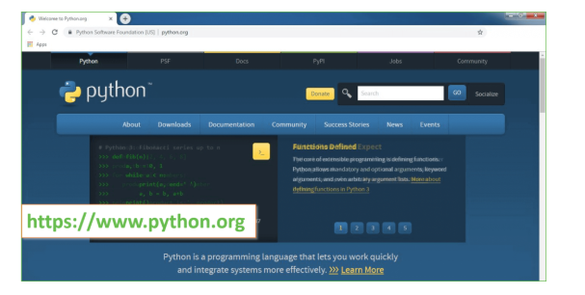
Now, check for the latest and the correct version for your operating system.
Step 2: Click on the Download Tab.
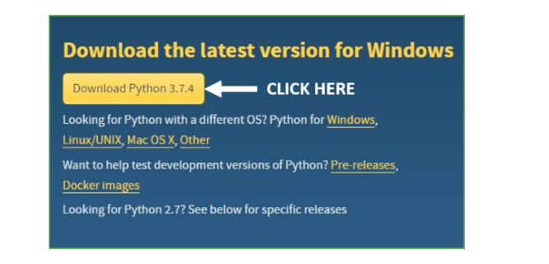
Step 3: You can either select the Download Python for windows 3.7.4 button in Yellow Color or you can scroll further down and click on download with respective to their version. Here, we are downloading the most recent python version for windows 3.7.4
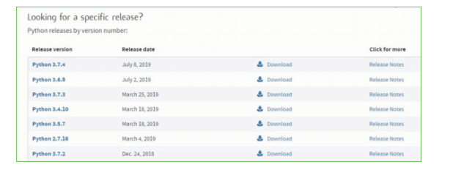
Step 4: Scroll down the page until you find the Files option.

Step 5: Here you see a different version of python along with the operating system.

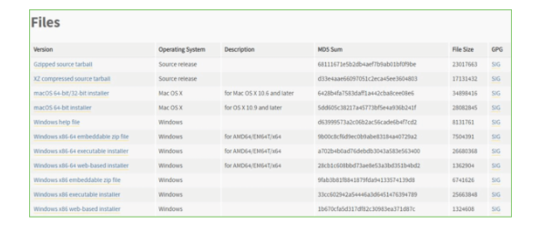

• To download Windows 32-bit python, you can select any one from the three options: Windows x86 embeddable zip file, Windows x86 executable installer or Windows x86 web-based installer.
•To download Windows 64-bit python, you can select any one from the three options: Windows x86-64 embeddable zip file, Windows x86-64 executable installer or Windows x86-64 web-based installer.
Here we will install Windows x86-64 web-based installer. Here your first part regarding which version of python is to be downloaded is completed. Now we move ahead with the second part in installing python i.e. Installation
Note: To know the changes or updates that are made in the version you can click on the Release Note Option.

Installation of Python
Step 1: Go to Download and Open the downloaded python version to carry out the installation process.
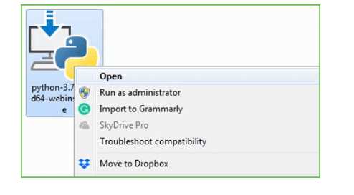
Step 2: Before you click on Install Now, Make sure to put a tick on Add Python 3.7 to PATH.

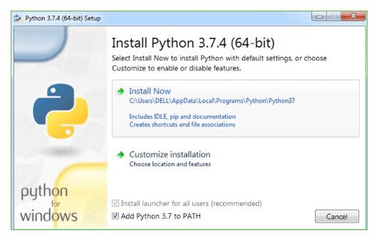

Step 3: Click on Install NOW After the installation is successful. Click on Close.

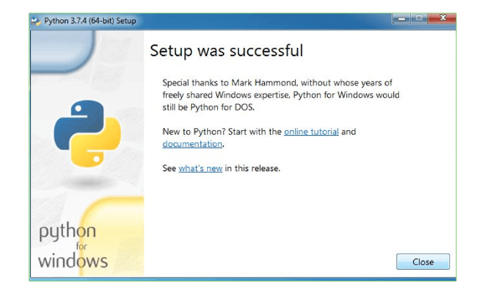

With these above three steps on python installation, you have successfully and correctly installed Python. Now is the time to verify the installation.
Note: The installation process might take a couple of minutes.

Verify the Python Installation
Step 1: Click on Start
Step 2: In the Windows Run Command, type “cmd”.

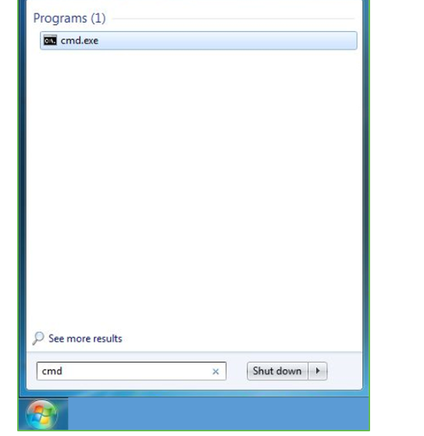
Step 3: Open the Command prompt option.
Step 4: Let us test whether the python is correctly installed. Type python –V and press Enter.

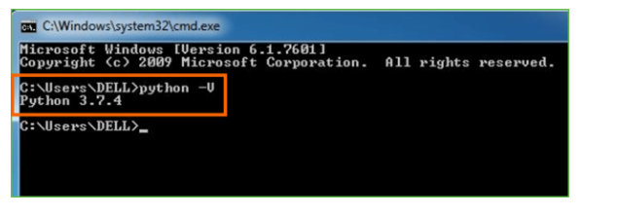
Step 5: You will get the answer as 3.7.4
Note: If you have any of the earlier versions of Python already installed. You must first uninstall the earlier version and then install the new one.

Check how the Python IDLE works
Step 1: Click on Start
Step 2: In the Windows Run command, type “python idle”.
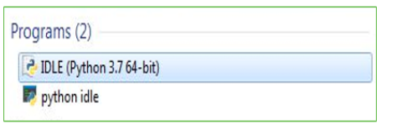
Step 3: Click on IDLE (Python 3.7 64-bit) and launch the program
Step 4: To go ahead with working in IDLE you must first save the file. Click on File > Click on Save

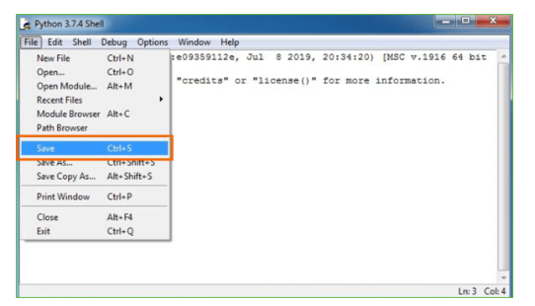
Step 5: Name the file and save as type should be Python files. Click on SAVE. Here I have named the files as Hey World.
Step 6: Now for e.g. enter print

SAMPLE CODE:
credentials_1 = {
'host':'xxx.yyy.com',
'port':'nnnn',
'username':'user',
'password':'password',
'database':'location',
'schema':'SMHEALTH'
}
def load_data_from_database(table_name):
return (
spark.read.format("jdbc").options(
driver = "com.ibm.db2.jcc.DB2Driver",
url = "jdbc:db2://" + credentials_1["host"] + ":" + credentials_1["port"] + "/" + credentials_1["database"],
user = credentials_1["username"],
password = credentials_1["password"],
dbtable = credentials_1["schema"] + "." + table_name,
partitionColumn = "patientid",
lowerBound = 1,
upperBound = 5000,
numPartitions = 10
).load()
)
observations_df = load_data_from_database("OBSERVATIONS")

observations_df.show(5)
from pyspark.sql.functions import col

systolic_observations_df = (
observations_df.select("patientid", "dateofobservation", "numericvalue")
.withColumnRenamed("numericvalue", "systolic")
.filter((col("code") == "8480-6"))
)

systolic_observations_df.show(5)
diastolic_observations_df = (
observations_df.select("patientid", "dateofobservation", "numericvalue")
.withColumnRenamed('numericvalue', 'diastolic')
.filter((col("code") == "8462-4"))
)

hdl_observations_df = (
observations_df.select("patientid", "dateofobservation", "numericvalue")
.withColumnRenamed('numericvalue', 'hdl')
.filter((col("code") == "2085-9"))
)

ldl_observations_df = (
observations_df.select("patientid", "dateofobservation", "numericvalue")
.withColumnRenamed('numericvalue', 'ldl')
.filter((col("code") == "18262-6"))
)

bmi_observations_df = (
observations_df.select("patientid", "dateofobservation", "numericvalue")
.withColumnRenamed('numericvalue', 'bmi')
.filter((col("code") == "39156-5"))
)
merged_observations_df = (
systolic_observations_df.join(diastolic_observations_df, ["patientid", "dateofobservation"])
.join(hdl_observations_df, ["patientid", "dateofobservation"])
.join(ldl_observations_df, ["patientid", "dateofobservation"])
.join(bmi_observations_df, ["patientid", "dateofobservation"])
)

merged_observations_df.show(5)
from pyspark.sql.functions import datediff

merged_observations_with_age_df = (
merged_observations_df.join(patients_df, "patientid")
.withColumn("age", datediff(col("dateofobservation"), col("dateofbirth"))/365)
.drop("dateofbirth")
)

merged_observations_with_age_df.show(5)

CHAPTER 7
SYSTEM TESTING

7.1TESTING STRATEGIES
Testing is the process where the test data is prepared and is used for testing the modules individually and later the validation given for the fields. Then the system testing takes place which makes sure that all components of the system property functions as a unit. The test data should be chosen such that it passed through all possible condition. Actually testing is the state of implementation which aimed at ensuring that the system works accurately and efficiently before the actual operation commence. The following is the description of the testing strategies, which were carried out during the testing period.
7.1.1 System Testing
Testing has become an System integral part of any system or project especially in the field of information technology. The importance of testing is a method of justifying, if one is ready to move further, be it to be check if one is capable to with stand the rigors of a particular situation cannot be underplayed and that is why testing before development is so critical. When the software is developed before it is given to user to user the software must be tested whether it is solving the purpose for which it is developed. This testing involves various types through which one can ensure the software is reliable. The program was tested logically and pattern of execution of the program for a set of data are repeated. Thus the code was exhaustively checked for all possible correct data and the outcomes were also checked.
7.1.2 Module Testing
To locate errors, each module is tested individually. This enables us to detect error and correct it without affecting any other modules. Whenever the program is not satisfying the required function, it must be corrected to get the required result. Thus all the modules are individually tested from bottom up starting with the smallest and lowest modules and proceeding to the next level. Each module in the system is tested separately. For example the job classification module is tested separately. This module is tested with different job and its approximate execution time and the result of the test is compared with the results that are prepared manually. The comparison shows that the results proposed system works efficiently than the existing system. Each module in the system is tested separately. In this system the resource classification and job scheduling modules are tested separately and their corresponding results are obtained which reduces the process waiting time.
7.1.3 Integration Testing
After the module testing, the integration testing is applied. When linking the modules there may be chance for errors to occur, these errors are corrected by using this testing. In this system all modules are connected and tested. The testing results are very correct. Thus the mapping of jobs with resources is done correctly by the system.
7.1.4 Acceptance Testing
When that user fined no major problems with its accuracy the system passers through a final acceptance test.This test confirms that the system needs the original goals, objectives and requirements established during analysis without actual execution which elimination wastage of time and money acceptance tests on the shoulders of users and management, it is finally acceptable and ready for the operation.

7.2. TEST CASES
Table 6.1 Test cases
S.NO | INPUT | OUTPUT | RESULT
Test Case 1  (Unit testing of Dataset) | The user gives the input in the form of Skin Disease Dataset. | An output is Predict Skin Disease Result. | A result is Predict Skin Disease Result.
Test Case 2  (Unit testing of Accuracy) | The user gives the input in the form of Skin Disease Dataset | An output is Predict Skin Disease Result. | A result is Predict Disease for test data using SVM algorithm got  Accuracy up to 95%.
Test Case 3  (Unit testing of Machine Learning Algorithms) | The user gives the input in the form of Skin Disease Dataset | An output is Predict Skin Disease Result. | A result is Predict Disease for test data using SVM algorithm got  Accuracy up to 95%.
Test Case 4  (Integration testing of Dataset) | The user gives the input in the form of  patient test data . | An output is Predict Skin Disease Result. | A result is Predict Disease for test data using SVM algorithm got  Accuracy up to 95%.
Test Case 5  (Big Bang testing) | The user gives the input in the form of patient test data . | An output is Predict Skin Disease Result. | A result prediction using ML algorithm like  RF,DT,SVM,Adaboost,Bagging & GB for Skin Disease Result.
Test Case 6  (Data Flow Testing) | The user gives the input in the form of Skin Disease Dataset | An output is Predict Skin Disease Result. | A result is Predict Skin Disease Result.
Test Case 7  (User interface Testing) | The user gives the input in the form of  Skin Disease Dataset | An output is Predict Skin Disease Result. | A result is Predict Skin Disease Result.
Test Case 8  (User interface Testing-Event based) | The user login in to application using username and password. | An output is user login successfully. | A result is user successfully login to application.
Test Case 9  (User interface Testing-Event based) | The user uploads dataset in to application. | An output is user upload dataset Successfully. | A result is user successfully upload dataset in to application.
Test Case 10  (User interface Testing-Event based) | The user gives the input in the form of Upload Skin Disease Dataset. | An output is Predict Skin Disease Result. | A result is predict health system using SVM algorithm got  Accuracy up to 95%.

7.3 RESULTS AND DISCUSSIONS

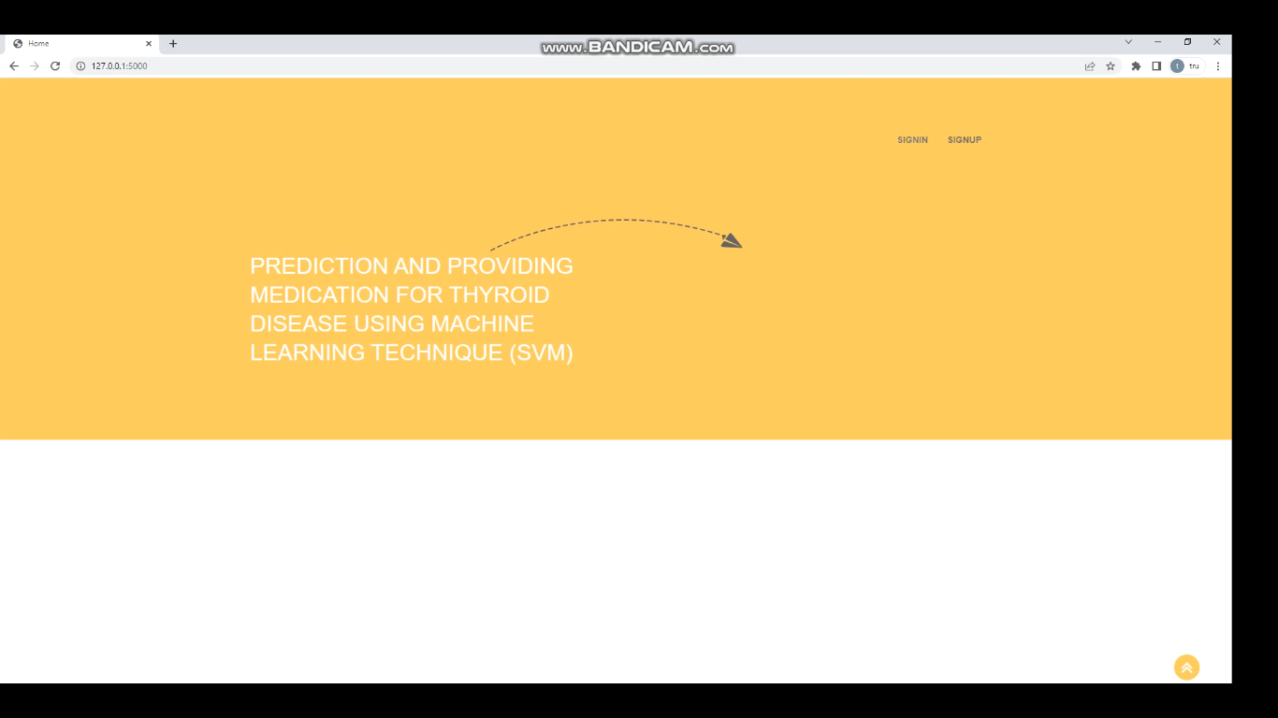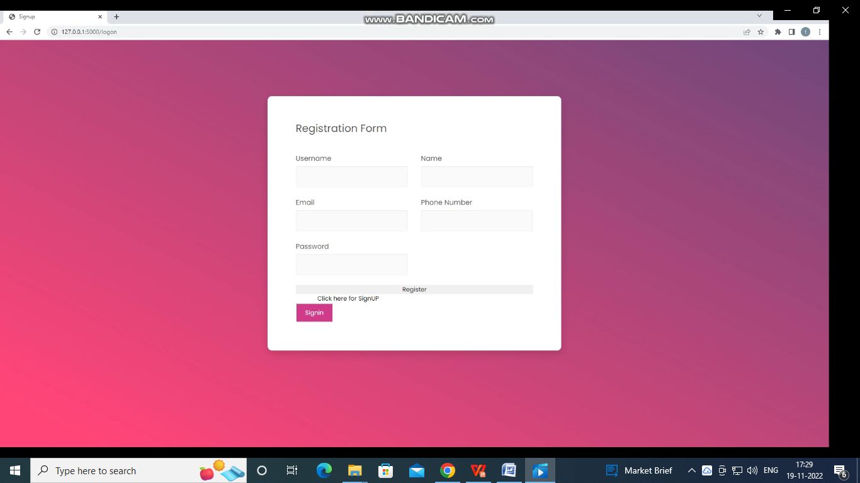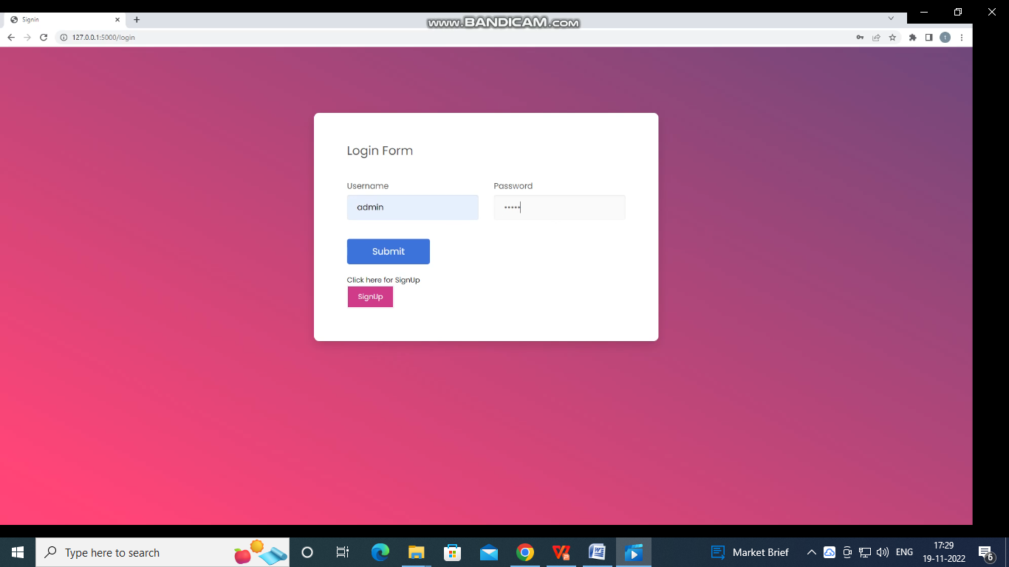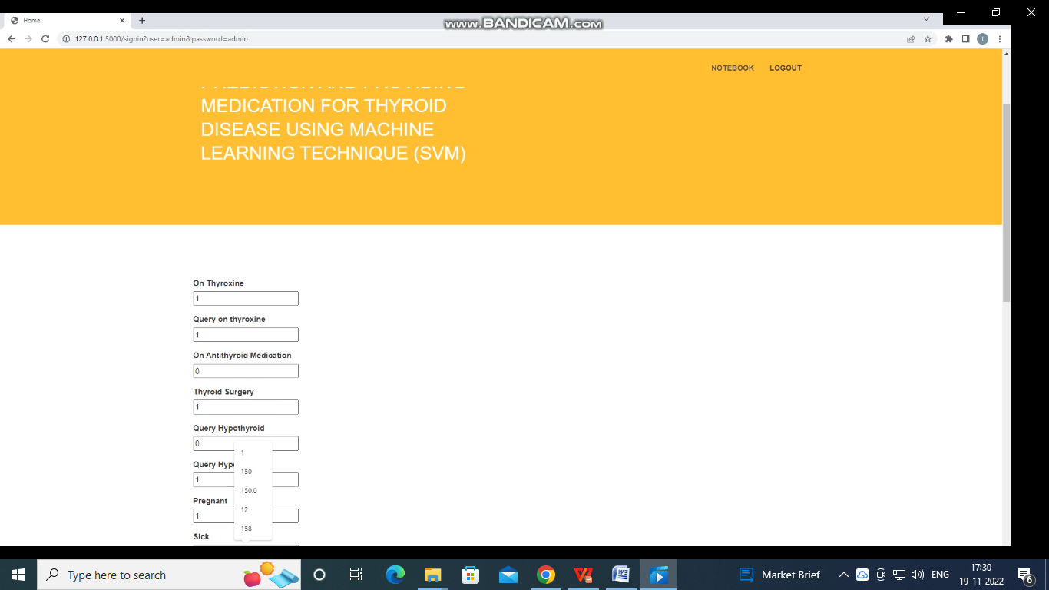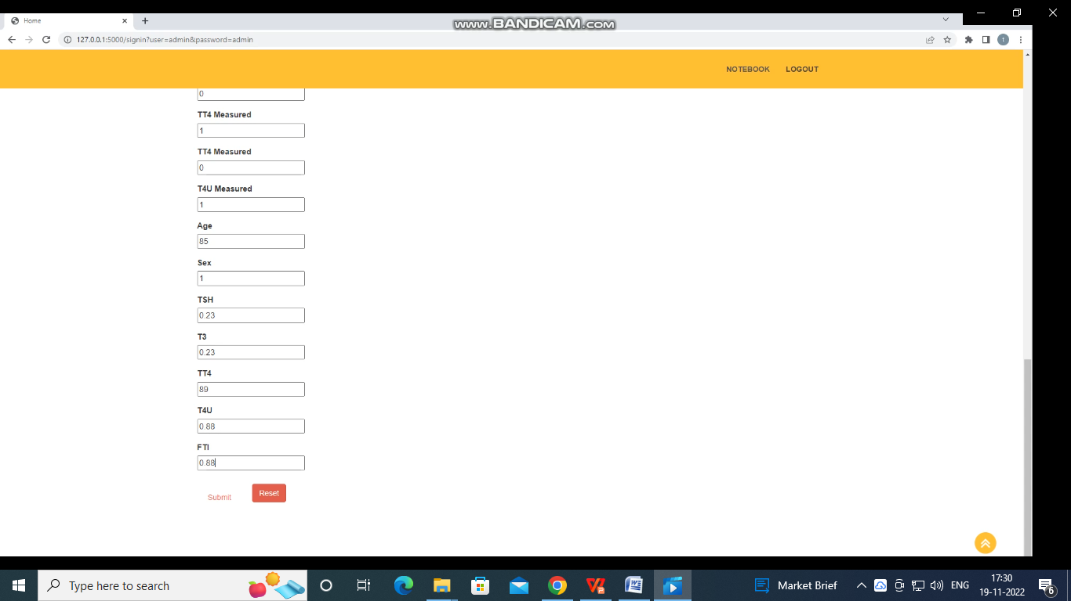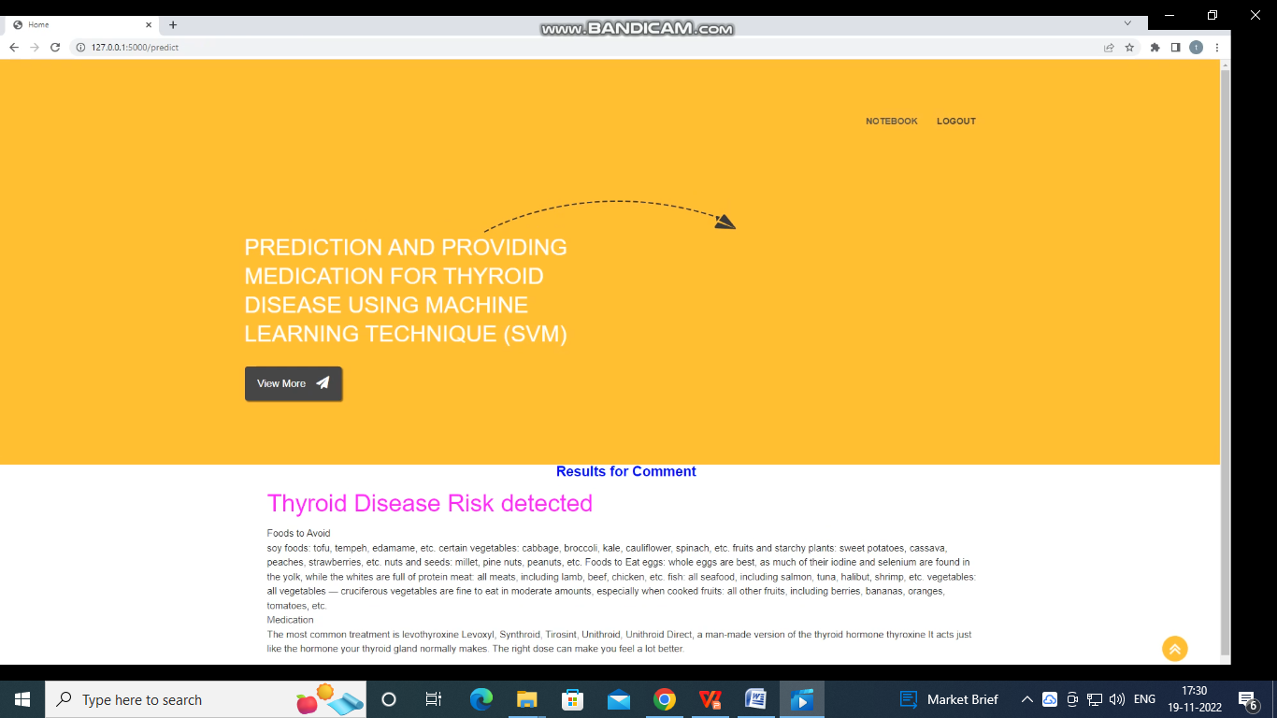

CHAPTER 8
CONCLUSION AND FUTURE ENHANCEMENT

8.1 CONCLUSION
The research work further studies the unusual machine learning strategies which can be mobilised in the diagnosis of thyroid diseases. In recent years, numerous approachable analyses for adequate and professional diagnosis of thyroid disease have been developed and used. Study reveals that various technologies used in both articles demonstrating different precision. Most academic papers indicate that the neural network outperforms other strategies. In other hand, also due to the fact that the help vector machine and decision tree have done well. There is no question that experts around the world have gained a great deal of improvement in diagnosing thyroid diseases, but it is recommended that number of criteria used by patients to diagnose thyroid disorders can be limited. More characteristics mean that a patient needs to perform a larger range of health evaluations that are both cost-effective and time-consuming.

8.2 FUTURE WORK:
Thus, certain algorithms and predictive models of thyroid disease need to be developed, requiring a minimum number of criteria for person to diagnose thyroid disease and saving patient's time and money. There are some ways that we thought can be further improved and implemented in the future work.

8.3 EXTENSION:
- In this paper the author had applied the SVM (accuracy is 90) and PCA with SVM (accuracy is 96).
- So as an extension we will apply some other algorithms like Random Forest, Decision Tree, Catboost, adaboost with PCA.
- To further more enhance SVM accuracy we will apply gridsearchcv to it.
- For this project we will implement Front end using Flask Framework as an extension.

9.REFERENCES
1.L. Ozyılmaz and T. Yıldırım, “Diagnosis of thyroid disease using artificial neural network methods,” in: Proceedings of ICONIP’02 9th international conference on neural information processing (Singapore: Orchid Country Club, 2002) pp. 2033–2036.
2.K. Polat, S. Sahan and S. Gunes, “A novel hybrid method based on artific ial immune recognition system (AIRS) with fuzzy weighted pre-processing for thyroid d isease diagnosis,” Expert Systems with Applications, vol. 32, 2007, pp. 1141-1147.
3.F. Saiti, A. A. Naini, M. A. Shoorehdeli, and M. Teshnehlab, “Thyroid Disease Diagnosis Based on Genetic Algorithms Using PNN and SVM,” in 3rd International Conference on Bio informatics and Biomedical Engineering, 2009. ICBBE 2009.
4.G. Zhang, L.V. Berardi, “An investigation of neural networks in thyro id function d iagnosis,” Health Care Management Science, 1998, pp. 29-37. Available: http ://www.endocrineweb.com/ thyroid.html, (Accessed: 7 August 2007).
5.V. Vapnik, Estimation of Dependences Based on Empirical Data, Springer, New York, 2012.
6.Obermeyer Z, Emanuel EJ. Predicting the future— big data, machine learning, and clinical medicine. NEngl J Med. 2016; 375:12161219.
7.Breiman L. Statistical Modeling: the two cultures. Stat Sci. 2001; 16:199-231.
8.Ehrenstein V, Nielsen H, Pedersen AB, Johnsen SP, Pedersen L. Clinical epidemiology in the era of big data: new opportunities, familiar challenges. Clin Ep idemio l. 2017; 9:245-250
9.Ghahramani Z. Probabilistic machine learning and artific ial intelligence. Nature. 2015; 521: 452-459.
10.Azimi P, Mohammad i HR, Benzel EC, Shahzadi S, Azhari S, Montazeri A. Artific ial neural networks in neurosurgery. J Neuro l Neurosurg Psychiatry. 2015; 86:251-256.
11.Deo RC. Machine learning in medicine. Circulation .2015; 132: 19201930. 12.P.C. Austin, J.V. Tu, J.E. Ho, D. Levy, D.S. Lee, Us ing methods from the data -mining and machine-learning literature for disease classification and prediction: a case study examining classification of heart failure subtypes, J. Clin. Epidemio l. 66 (4) (2013)398–407.
13.A.K. Pandey, P. Pandey, K.L. Jaiswal, A heart d isease prediction model us ing Decis ion Tree, IUP J Comput. Sci. 7 (3) (2013) 43.
14.S. Ismaeel, A. Miri, D. Chourishi, in: Using the Extreme Learning Machine (ELM) technique for heart disease diagnosis, IEEE Canada International Humanitarian Technology Conference, 2015, pp. 1–3.
15.L. Verma, S. Srivastava, P.C. Negi, A hybrid data mining model to predict coronary artery disease cases using non-invasive clinical data, J. Med. Syst. 40 (7) (2016) 1–7.

